Orientation Activity

Top of Form

Bottom of Form

**M1T1: Orientation Assignment**

[M1T1: Orientation Assignment](https://faytechcc.blackboard.com/webapps/blackboard/content/listContent.jsp?course_id=_33824_1&content_id=_5842748_1)

**This assignment is due by 8am Monday 8/23. Completing it by the due date is mandatory for continued enrollment in the class.**

In the past we've used the first mandatory assignment as a "getting to know you" post -- this is similar, but using C++.

**Instructions**

Using your choice of C++ development environment (Code::Blocks, repl.it, etc.), create a program that meets the following requirements.

The program should be named **M1T1_Lastname.cpp**, with your own last name replacing "Lastname". (10 points)

The file should begin with the standard FTCC program header (10 points). Here's an example as a reminder.

Tthe program should print at least three lines of text when run (70 points).

* + Your first and last name
  + What languages (including C++) you are currently studying this semester
  + Any additional information about yourself you'd like to volunteer -- job, hobbies, interests, etc.

Finally, ZIP this file (10 points) into **M1T1_Lastname.zip** (again, with your own name instead) and upload it to the link below to complete this assignment.

**linked item**[**Module One**](https://faytechcc.blackboard.com/webapps/blackboard/content/launchLink.jsp?course_id=_33824_1&content_id=_5958810_1&mode=view)

This link will lead you to the Module One assignments, including M1T1.

**Course Textbook**

[Course Textbook](https://faytechcc.blackboard.com/webapps/blackboard/content/listContent.jsp?course_id=_33824_1&content_id=_5842748_1)

To access the course textbook, you can either purchase a code from the FTCC textbook, or follow the instructions below.

* + Sign in or create an account at learn.zybooks.com
  + Enter zyBook code:    FAYTECHCCCSC234NorrisFall2021
  + Subscribe

A subscription is **$77**. Students may begin subscribing on Jul 18, 2021 and the cutoff to subscribe is Nov 30, 2021. Subscriptions will last until Jan 03, 2022.

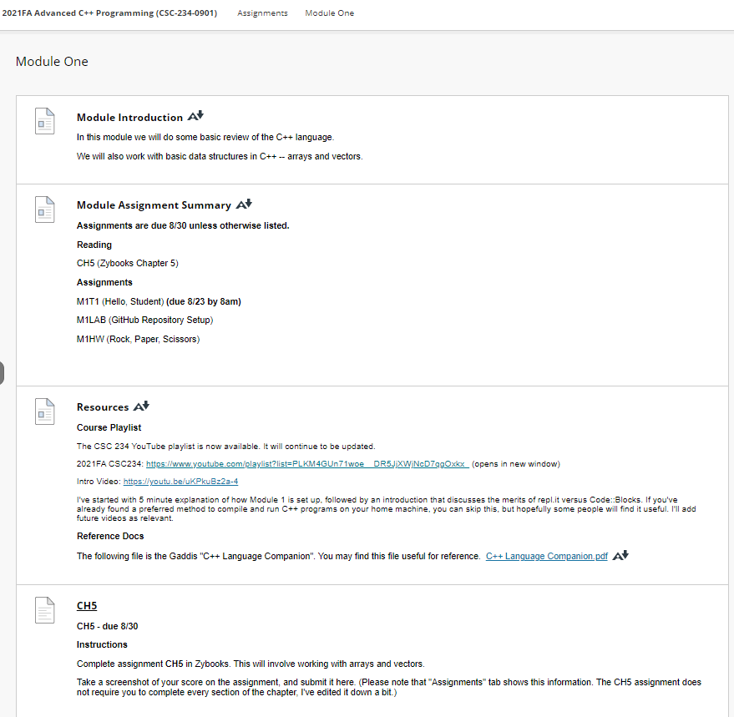

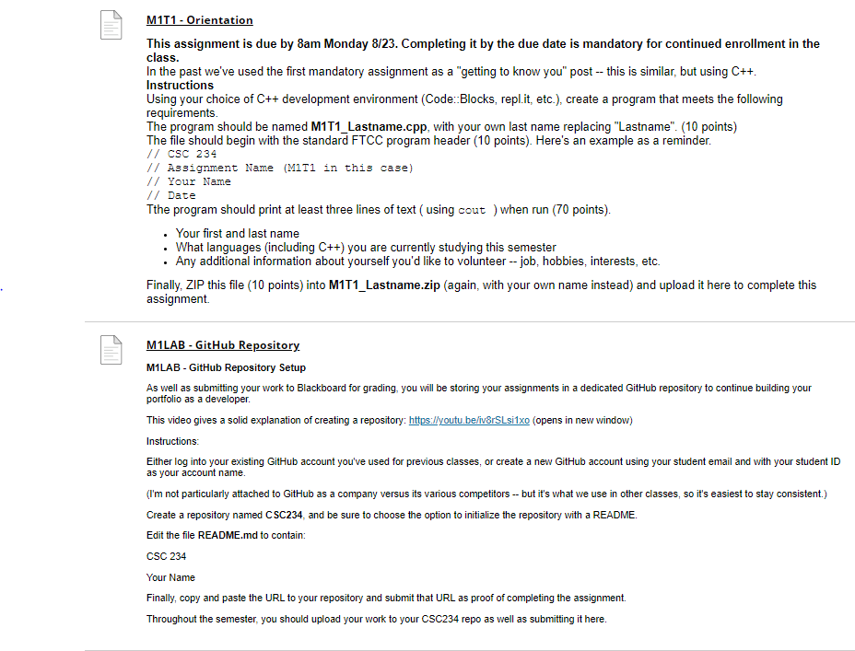

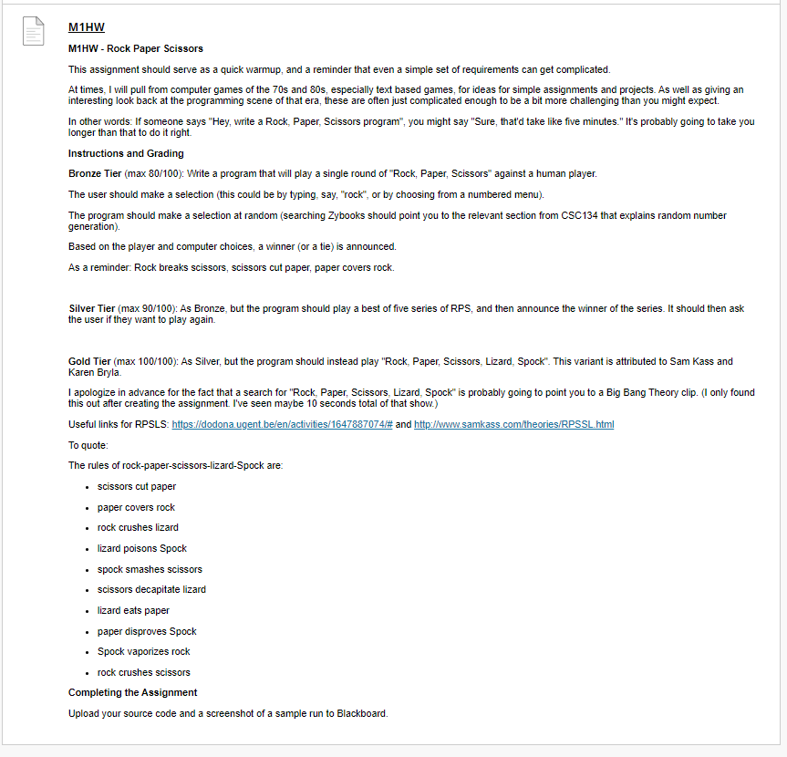

### Resources

[Resources](https://faytechcc.blackboard.com/webapps/blackboard/content/listContent.jsp?course_id=_33824_1&content_id=_5842751_1&mode=view)

**Course Playlist**

The CSC 234 YouTube playlist is now available. It will continue to be updated.

2021FA CSC234: <https://www.youtube.com/playlist?list=PLKM4GUn71woe__DR5JjXWjNcD7qgOxkx_> (opens in new window)

Intro Video: <https://youtu.be/uKPkuBz2a-4>

I've started with 5 minute explanation of how Module 1 is set up, followed by an introduction that discusses the merits of repl.it versus Code::Blocks. If you've already found a preferred method to compile and run C++ programs on your home machine, you can skip this, but hopefully some people will find it useful. I'll add future videos as relevant.

**Reference Docs**

The following file is the Gaddis "C++ Language Companion". You may find this file useful for reference.  [C++ Language Companion.pdf](https://faytechcc.blackboard.com/bbcswebdav/pid-5842754-dt-content-rid-54063186_1/xid-54063186_1) [C++ Language Companion.pdf - Alternative Formats](https://faytechcc.blackboard.com/webapps/blackboard/content/listContent.jsp?course_id=_33824_1&content_id=_5842751_1&mode=view)